BEGINNING OF INDIAN CIVILIZATION

🏛️ What is Civilization?
- A civilization is a developed and advanced stage of human society.
- It includes cities, writing, art, architecture, religion, economy, and a stable government.
- Civilizations show a high level of cultural and technological development.
- Harappan Civilization or Indus Valley Civilization was one of the earliest civilizations in the world (around 2500 BCE).

🏙️ Town Planning of Indus Valley Civilization
- Cities were well-planned with a grid system (streets cut at right angles).
- Two parts of the city: Citadel (upper part) and Lower Town (residential area).
- Houses made of baked bricks and often had courtyards and wells.
- Some cities like Harappa, Mohenjo-daro, and Lothal show excellent town planning.

🛁 The Great Bath
- Found in Mohenjo-daro.
- A large rectangular tank used possibly for ritual bathing.
- Surrounded by rooms and had steps leading to the pool.
- Water-tight with special bricks and bitumen (a type of tar).

💧 Water Management and Drainage System
- Every house had access to water through wells.
- Advanced drainage system—drains were covered and ran along streets.
- Drains had inspection holes for cleaning.
- Houses connected to the main drains showing a concern for public hygiene.

🏯 Citadel
- A raised area built on a platform of mud bricks.
- Housed important buildings like the Great Bath, granaries, and assembly halls.
- Possibly used by priests or rulers for administration or rituals.
- Indicated a system of centralized planning and control.

🌾 Crops and Agriculture of Harappa
- Main crops: wheat, barley, peas, sesame, mustard, and cotton.
- First civilization to grow cotton.
- Used wooden ploughs pulled by oxen.
- Agriculture was supported by fertile soil and river water (Indus and its tributaries).

🔖 Seals
- Made of steatite (a soft stone).
- Carved with animals, symbols, and short scripts.
- Used for trade and identification of goods.
- Some seals have figures like unicorns, bulls, and the Pashupati (proto-Shiva figure).

⚰️ The End of Indus Valley Civilization
- Around 1900 BCE, the civilization started to decline.
- Possible reasons:
  - Floods or earthquakes.
  - Change in the course of rivers (especially the Indus).
  - Decline in trade with Mesopotamia.
  - Invasion by foreign tribes (like the Aryans—debatable).
  - Environmental changes (droughts, soil degradation).
- Cities were gradually abandoned.

MCQ’S PRACTICE SET:
1.Which crops were commonly grown by the Harappans?
(a) Corn and tomatoes
(b) Potatoes and carrots
(c) Pineapples and mangoes
(d) Barley and wheat
2.What was one of the primary reasons for the growth of villages and towns in the Indus-Sarasvati region?
(a) Advancement in metallurgy
(b) Increased trade and exchanges
(c) Discovery of gold mines
(d) Development of art and architecture
3. Assertion (A) The Harappan civilisation had a highly organised urban planning system.
Reason (R) The streets in Harappan cities were wide and aligned with the cardinal directions.
4. Assertion (A) Harappan seals were primarily used for religious rituals.
Reason (R) The seals often depicted animals and symbols and were used in trade activities as a mark of identity.
5.Which of the following statement is or are INCORRECT?
Statement I- The Great Bath at Mohenjo-daro was a large reservoir for storing drinking water.
Statement II- The Harappan civilisation was characterised by its rural planning.
Statement III- Harappans imported tin to mix with copper to produce bronze, which was used to make tools and other artefacts.
- Statement I and II are INCORRECT
- Statement II and III are INCORRECT
- Only Statement I is INCORRECT
- Statement I ,II and III are INCORRECT

6. Koushik visited a museum where he saw a small, flat object made of stone with an animal figure and some symbols engraved on it. He was told it belonged to the Indus Valley Civilization. What was he most likely looking at?

(a) An ancient coin
(b) A brick
(c) A tool
(d) A seal

7. A civil engineer is studying ancient drainage techniques to plan modern eco-friendly towns. Which feature of the Indus Valley Civilization would most inspire her?
(a) Use of fire altars for worship
(b) Underground drains connected to every house
(c) Roads made of stone and mud
(d) Wells built only for rich people

8.Match the column:
1. Mohenjo-daro | a. City divided into Citadel and Lower Town
2. Great Bath | b. Used for water storage and rituals
3. Dockyard | c. Found in Lothal
4. Granary | d. Used to store surplus grain
5. Town Planning | e. Located in present-day Pakistan

SUBJECTIVE QUESTIONS
1.What was the significance of Lothal in Harappan trade?
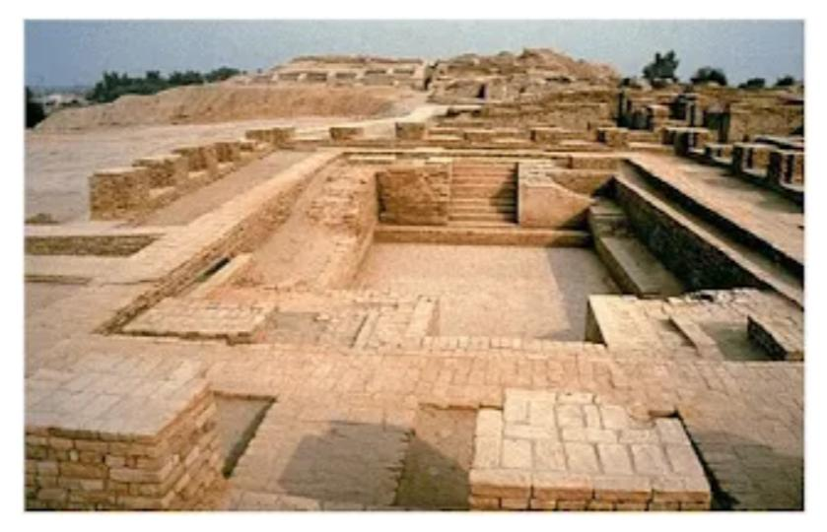
2.Identify the architecture explain its significance

3.Explain how the people of the Indus Valley managed water and waste in their cities. What does this tell us about their way of life.
4. How did agriculture support the growth of the Indus Valley Civilization? Mention three crops they grew.
5. What were seals used for in the Indus Valley Civilization? Describe one feature of these seals
6. List the ornaments used by the Indus Valley people. What do these ornaments tell us about their lifestyle?
7. Imagine you are an architect visiting Mohenjo-daro. Based on your visit, describe how the planning of houses and streets shows the people’s concern for cleanliness and order.

